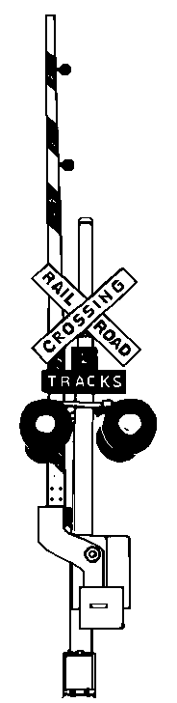

By N-Scalers for N-Scalers

September 10 & 11, 2005

Saturday Sept. 10th, 10 AM till 5 PM
Sunday Sept. 11th, 9 AM till 3 PM

Bedford Fairgrounds
4-H Building
Bedford, Pennsylvania

“N-Weekend” participant $8.⁰⁰
For a participant “N-Scale Weekend” order form
Call or E-mail info below

General Admission: $3.⁰⁰

Under 12 Free w/ adult

N-Scale Model Trains & Supplies
Vendors: MB Klein, Mailbag Hobbies, HB Peterson, Mike Bencs, N-Cellar, Wireless Micro Color Cam, Steve Wilson & Barry Wingard
7 Large Operating N-Scale Train Layouts
Layouts: Baltimore Area N-Trak, Northern Virginia NTRAK, Twin Tiers N-Trak,
Middle Division N-Trak, Penn-N-Scalers & Bedford N-Scalers
Sponsored by: Bedford Model Railroaders
For More Information: Mike Phillips 814-623-2239
or e-mail: miknscale@yahoo.com

